Report of | Meeting | Date
Head of Audit and Risk | Governance Committee | Tuesday, 6 February 2024

Risk Management Strategy

Is this report confidential? | No.

Is this decision key? | No

Purpose of the Report

- The Risk Management Strategy was last updated and presented to the Governance Committee in March 2021. This has now been reviewed and updated to include the Council’s risk appetite and escalation processes.

Recommendations

- Members consider and approve the revised Risk Management Strategy.

Reasons for recommendations

- The Governance Committee’s Terms of Reference sets out the committee’s responsibility to monitor the effective development and operation of risk management in the Council. This report allows the committee to fulfil that role.

Other options considered and rejected

- Not applicable.

Corporate priorities

- The report relates to the following corporate priorities: (Please bold one)

An exemplary council | Healthy and happy communities
Opportunities for everyone | Green and clean neighbourhood

Background to the report

- The Risk Management Strategy sets out how the Council manages potential risks and opportunities it faces in pursuit of its objectives. It is important to recognise that risk management is not about avoiding risks, rather it is about how an understanding of the nature of risk and how it can help the Council make more informed decisions in order to maximise the efficiency of our services.

    - It was recognized in the 2023 Annual Governance Statement that the Risk Management Strategy should be strengthened and included the following action:

Define risk management appetite and implement escalation and reporting mechanisms for non-strategic risk.
- In addition, the Internal Audit Annual Report and Opinion for 2022/23 assessed the effectiveness of the Council’s Risk Management arrangements, based on the Chartered Institute of Internal Auditors’ Risk Maturity Model.

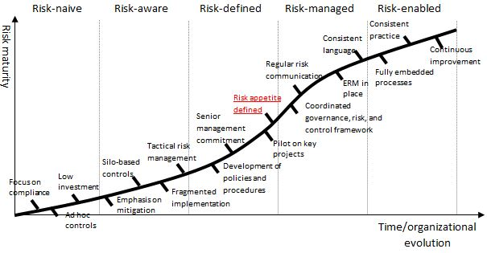
- The conclusion was that the Council’s risk management maturity is largely risk defined. In order to become risk managed, the Council needs to ensure work is undertaken to define its risk appetite, monitoring and reporting arrangements and embed risk management within all operational service areas.

- The management of risk and use of GRACE across all categories of risk is improving and the introduction of a risk appetite and escalation processes will strengthen and further embed the current arrangements.

Revision to the Risk Management Strategy
- The Risk Management Strategy at Appendix A has now been revised to include the Council’s risk appetite and escalation processes for risks which are deemed to be outside of the appetite. For ease, all changes are highlighted in red and have been agreed with the Senior Management Team.

- At this stage, the risk appetite has been established to incorporate all differing categories of risks. In future, as the Council becomes more risk managed, it may be appropriate to establish differing levels of risk appetite for each category.

- The Council need to ensure that identified and recorded risks are complete and appropriately scored and by adopting this strategy will set the framework for escalating risks which are falling outside of the agreed levels.

- Once approved, robust arrangements will be developed to ensure compliance with the new reporting requirements to ensure risks are maintained in accordance with the agreed risk appetite or further mitigation measures applied.

Climate change and air quality

- The work noted in this report does not impact the climate change and sustainability targets of the Councils Green Agenda and all environmental considerations are in place.

Equality and diversity

- An impact assessment has been completed and has not identified any issues.

Risk

- Risk management is an essential part of CIPFA’s Delivering Good Governance in Local Government Framework. The adoption and application of the Risk Management Strategy allows the Council to demonstrate the effective management of risk.

Comments of the Statutory Finance Officer

- The Risk Management Strategy provides a means of demonstrating that all significant risks are being identified, reviewed and appropriately assessed. It also serves to help protect the Council’s financial resources and assets and to ensure that they are directed to key priorities.

- There are no additional costs directly linked to this Strategy.

Comments of the Monitoring Officer

- A degree of risk is inherent in much of what we do as a council. It is important that we have in place practices whereby risks are identified and managed. This is what the revised Risk Management Strategy is intended to contribute to.

Background documents

There are no background papers to this report.

Appendices

Appendix A – Risk Management Strategy

Report Author: | Email: | Telephone: | Date:
Dawn Highton (Head of Audit & Risk) | dawn.highton@southribble.gov.uk | 01772 376639 | 21.12.23

